The Dungeon’s Jewel Game Design Document

Author:

Joseph Martinez

Title:

The Dungeon’s Jewel

Concept:

A chance game based around the concept of a dungeon crawler. 4 player game, played on a 7X7 board, where each player starts on a corner. There is a jewel on the very center most tile on the board. Each player takes turns moving toward the jewel. The goal is to collect the jewel and bring it back to the player’s starting position.

Game flow:

Players decide who goes first by rolling one die. Person with the highest roll goes first and the turns then follow clockwise. On a player’s turn, they must decide which adjacent space they want to move to. Adjacent spaces do not include diagonal spaces (a player can only move up, down, left, or right if there is a space to move to in that direction). Once a player decides on a space to move to, they must announce the space they are going to move to and draw a dungeon token from the dungeon token pile. Once a dungeon token is drawn it is attributed to the tile the person who drew it is currently on. The person who drew the token can read the token to see what type of hazard is affecting them in the current room. The player can now place the token face down on the space they want to move to, and then move to that space. The player can choose to keep the hazard on the space as a secret so that when other players land on the space, they do not know what hazard awaits them. The player then rolls to see if they survive the hazard on the space, or use one of their items to survive the hazard. A roll of three or higher is a successful roll.

If a player survives the hazard, then they get to pull a loot card. The player must reveal what they got to the other players. Loots are either items that help with surviving hazards in dungeons, or items that increase attack power. Attack power helps with defeating monsters and the final boss at the center of the board. Attack power starts at zero, and increases by one every time a person gets an item that increases their attack power.

If the player does not get a high enough roll, then they lose one health. Players start with two health, and if their health goes to zero, they start over with three health, but must move back to their beginning square.

If the space that the current player decided to move toward already has a dungeon token currently on it, then the player can look at the token to see what hazard awaits them, instead of redrawing a new token.

Players continue taking turns trying to make it toward the objective at the center of the game. Once players make it to the space at the center of the game, they must roll two dice to defeat the “dragon” that is also at the center of the board. On this turn, a player’s roll consists of their attack power, plus what they roll on the dice. A player must roll must be a total of ten or higher to defeat the dragon. If a player fails to defeat the dragon, then they lose health in the same way they would if they did not survive a hazard. If the player succeeds, then they can move to any space surrounding the center space. The player must now make it back to their starting space. At this point, all other players will attempt to defeat the player who has the jewel. If the player makes it to their starting space, then it is game over.

Attacking:

Players can attack each other if the current player is adjacent to another player. If the player decides to attack another player, then the two players roll a die and add that roll to their attack power. Whoever has the highest roll plus attack power wins. Hazards are ignored during attacking phases. If the attacking player wins, then the other player loses a health point. If the attacked player wins, then the attacking player loses a health point. If it is a tie, neither player loses any health. At the end of the attacking phase, both players should still be on the same space that they started on. If a player decides to attack, then they cannot move for that turn.

Special dungeon tokens:

Some dungeon tokens contain a monster on them. These tokens indicate that a player must defeat a monster. A player rolls a dice and adds it to their attack power, and this sum must be higher than 5 for the person to survive the hazard.

Materials provided:

Dungeon tokens

Treasure cards

Board

Player icons

Materials needed:

Surface to play on

The Dungeon’s Jewel Rulebook

**Objective:**

The object of the game is to gain the jewel at the center of the game board by collecting loot through surviving hazards and bring this jewel back to your starting space

**Setup:**

Players lay out the game board and put each of their pieces on a corner of their choice. Players also designate a player to shuffle both the dungeon token pile, and the treasure card pile. The person who shuffled starts first. If no one can decide, then there is a die roll. The person who rolls the highest has to shuffle and start first. The game board is put in the center nearest the most amount of people, and the two piles are placed next to the board.

**Basic Rules:**

Players start their turn by decided which space they want to move to. Spaces that are adjacent excluding diagonals are legal moves. Once a player makes their decision they must announce it to the rest of the players. Then the player draws a dungeon token. The player reads the dungeon token without anyone else seeing, and then places it face down on the space that they are going to move to, and then moves to that space. The player then rolls to see if they survive the hazard indicated on the token. If the player has an item that helps them with surviving the hazard on the space, then they do not have to roll the die, and simply survive the hazard. If the player does not have an item that helps them with surviving the current hazard in the room, then they must roll. A roll of 4 or higher means the player survived the hazard and does not have to take damage, and they get to pull a treasure card (see treasure card for additional details). If a player does not roll a 4 or higher, then they take damage, and lose a health point. Players start with two health points. If a player loses a health point, but still has a health point remaining, then they stay on the space that they moved to. If a player loses a health point, and does not have any health points left, then they must move back to their starting space. Once a hazard is drawn and placed on a space, it remains on that space for all other players to survive if they move to that space. Players take turns moving through spaces, and can attack players if they are adjacent to them, but if they choose to attack, then they cannot move for a turn (see attacking for additional details). If a player makes it to the center space, they do not draw a hazard card, but instead always face the same hazard. At the center is a jewel guarded by a dragon. If the player makes it to this space, they must roll two dice, and add that roll to their attack power. This sum must be higher than ten. If the sum is higher than 10, then the player gets the jewel, and on their next turn, moves to any space surrounding the center space. If the player does not get a high enough roll, then they take damage in the same way that they would if they had not survived a hazard. Once the player defeats the dragon, they must make their way toward their starting space. If the player is attacked by another player and defeated, them that player gains the jewel and must make it to their starting space. If they make it to their starting space, then the game is over and that player wins.

**Additional Rules:**

Attacking:

Players can attack other players if they are adjacent to the player they want to attack. If the player chooses to attack another player, then both players roll a die, and add the roll to their attack power. The player with the highest sum wins and the losing player takes damage. Hazards are ignored during attacking. The attacking player cannot move during this turn.

Attack Power:

Players gain attack power by collecting items. Certain loot add one to attack power. Attack power starts at zero and goes up by one for every attack power item a player has.

Loot:

There are two kinds of items that can be gotten from loot, items that add to attack power, and item that allow players to easily survive hazards. If a player has an item that corresponds to a dungeon token, then they do not have to survive the hazard, and can take the loot from within a room without having to do a dice roll. Loot is only gotten the first time a player enters a room. If there is already a token face down on the spot a player is moving toward, then the player can only survive the hazard, but cannot gain any loot from the room.

Items:

Hazard Survival:

Spike boots: Allows players to survive the spike hazard.

Awakening spell: Allows players to survive the sleeping gas hazard.

Fire resistant cloak: Allows players to survive the fire hazard.

Winged shoes: Allows players to survive the trap door hazard.

Water Breathing spell: Allows players to survive the water hazard.

Walk through walls spell: Allows players to walk through a wall.

Poison treatment: Allows players to survive the poison dart hazard.

Lightweight shoes: Allows players to survive the quicksand hazard.

Attack power increase:

(All increase attack power by one).  
Broadsword

Shield

Boots

Helmet

Legs

Gloves

Chest

Arms

Special spaces:

Trap door: If a player encounters the trap door hazard, then the player rolls like usual. If successful, then the player survives the hazard with the usual rules. If the player fails, then the player does not lose a health point, but does move back to their starting position.

Monster: If a player encounters the monster hazard, then the player must defeat the monster. The player must roll the die and then add it to their attack power. The sum must be higher than 5. The survival rules remain the same.

Wall: If a player draws a wall dungeon token, then they get to decide which way it is facing, and must leave it facing up to remind players which way the wall is facing. The player does not need to roll, and also does not get any loot.

Dungeon tokens:

|  |  |  |  |  |  |  |
| --- | --- | --- | --- | --- | --- | --- |
| Image result for spike symbol  Spike Dungeon Token | Image result for rushing water symbol  Water  Dungeon Token | Image result for fire symbol  Fire Dungeon  Token | Image result for minotaur clipart  Monster  Dungeon  Token | Trap Door  Dungeon Token | Image result for smoke clip art  Sleeping gas  Dungeon Token | Image result for blow dart clipart -frog  Poison Dart  Dungeon Token |
| Image result for quicksand clipart  Quicksand Dungeon Token | Image result for thick line  Wall  Dungeon  Token |  |  |  |  |  |

Game Space Diagram:

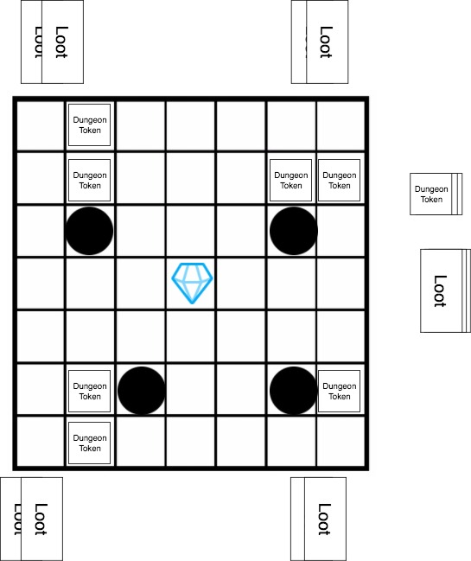

Game State Diagram:

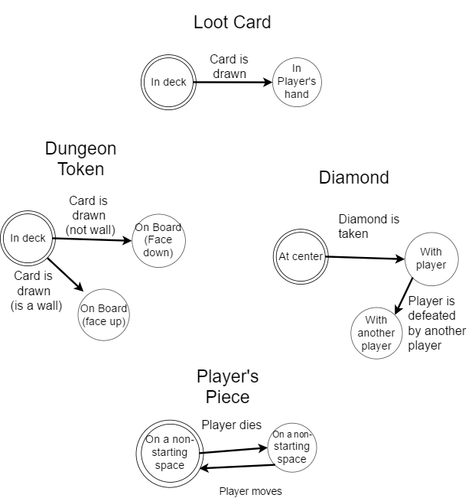

Game Flow Diagram:

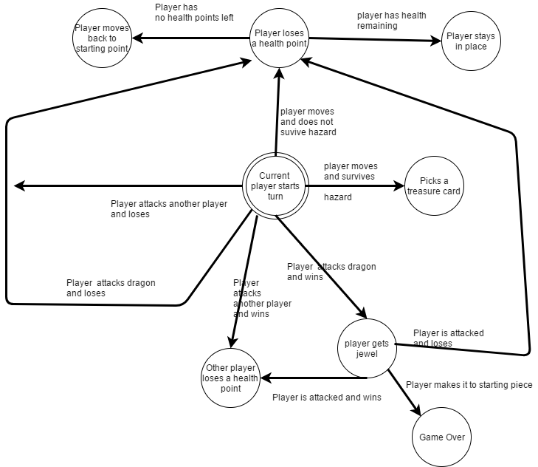

Revision log

* After playing with friends:
  + Lowered the requirements of beating the dragon to rolling a 9, as players were discouraged from attacking until late into the game, and made the game too long.
  + Items ran out quickly, and certain players may never get items that added to their attack power, so to solve this, I added an extra rule that stated that players can take one item from a player they defeat.
  + Decided to make game board bigger and add descriptions onto the dungeon tokens, as I had to keep reminding players what each token meant, and how they could survive the hazard indicated on that token.
  + Used lego blocks for player’s pieces and two smaller blocks on top of the piece to indicate health. Players take one off when they lose health.

Post Mortem

Players often just walked randomly until they what they felt was a comfortable amount of attack power, and this happened usually around the same time. Once this happened all players would try to make it to the center first. The player who started the game usually has a significant advantage. Players will often only attack once a player has a jewel. Players found the attacking mechanic to be somewhat broken, as it benefited the attacked player more often than the attacking player, as a player must move in one turn, and attack in another, which made avoiding being attacked very easy. Ultimately, most games would boil down to who got the luckiest rolls and got the best gear first, and then once they got the diamond they were basically free to go back to their starting square.

Game is mostly broken, if I can fix the fighting mechanic, and find a way to make movement more strategic, then it might have a chance, but for now it is a somewhat broken game.